9.ADC Calibration with ESP 32(Practical)

Circuit Diagram:

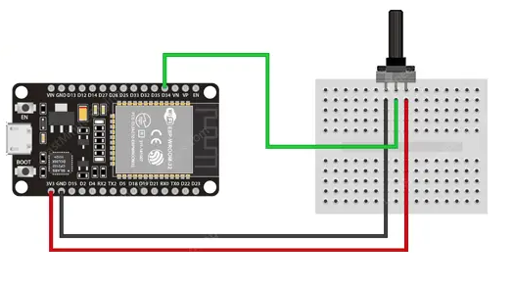

9.(A).ADC Calibration with ESP 32(Practical)
Source code:

#include "esp_adc_cal.h"

#define AN_Pot1 35

int AN_Pot1_Result = 0;
float Voltage = 0.0;

void setup()
{
Serial.begin(115200);
}

void loop()
{
AN_Pot1_Result = analogRead(AN_Pot1);
Voltage = readADC_Cal(AN_Pot1_Result);
Serial.println(Voltage/1000.0); // Print Voltage (in V)
//Serial.println(Voltage); // Print Voltage (in mV)
delay(1000);
}

uint32_t readADC_Cal(int ADC_Raw)
{
esp_adc_cal_characteristics_t adc_chars;

esp_adc_cal_characterize(ADC_UNIT_1, ADC_ATTEN_DB_11, ADC_WIDTH_BIT_12, 1100, &adc_chars);
return(esp_adc_cal_raw_to_voltage(ADC_Raw, &adc_chars));
}
9.ADC read using LED dimmer using ESP 32(Skilling)

Circuit Diagram:

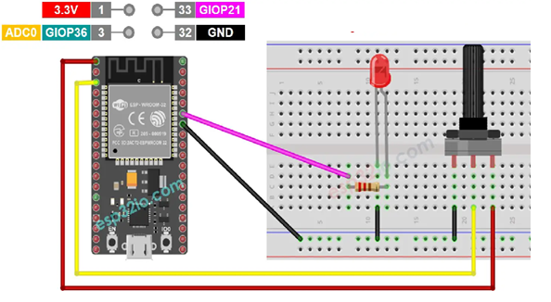
Source code:

// Define constants
const int potPin = 35; // Analog input pin for potentiometer
const int ledPin = 21; // PWM output pin for LED

void setup() {
// Initialize serial communication
Serial.begin(115200);

// Configure LED pin as an output
pinMode(ledPin, OUTPUT);
}

void loop() {
// Read the analog value from the potentiometer
int potValue = analogRead(potPin);

// Map the potentiometer value (0-4095) to the LED brightness (0-255)
int brightness = map(potValue, 0, 4095, 0, 255);

// Print the potentiometer value and set the LED brightness
Serial.print("Potentiometer Value: ");
Serial.print(potValue);
Serial.print(" Brightness: ");
Serial.println(brightness);

// Set the LED brightness using PWM
analogWrite(ledPin, brightness);

// Add a delay to make the changes noticeable
delay(5000);
}

